ASR Live report changes

Request Date: 28 Jan 2015

Description:

Request to change Report Chart layout for 2 reports:

Storage history report by Storage type,

Storage history report by Bin type

I have 2 queries as below for your kind advice:

1. Is it possible to configure storage utilization by bin type on Weekly as the X-axis?

Something like this:

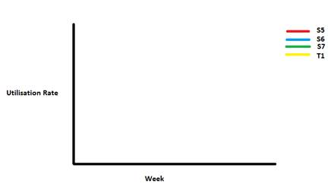

**Current Report**

